The whole document will follow Times New Roman font, Justified alignment, 2 point spacing with no space before and after paragraph

TITLE <Times New Roman, 16pt, Bold, Centered)>
Author¹, Author², Author³ …… (Times New Roman, 14pt, Centered)
¹Affliation
²Affliation
³Affliation
Email ID:
ORCid:
(Provide the email ID and ORCid of the Corresponding Author) (* mark for corresponding author)

ABSTRACT (Times New Roman, 12pt, Justified, Bold Uppercase)
The……………………………………………………………………………………………………………………………………………………………………………………….
Keywords:
( 250 – 300 words, Times New Roman, 12pt, justified, 5 to 7 keywords)

1. FIRST LEVEL HEADING
(Times New Roman, Bold, 12pt, Uppercase) start the content as a new paragraph.
1.1 Second Level Heading
(Times New Roman, Bold, 12pt, Capitalize Each Word) start the content as a new paragraph.
1.1.1 Third Level Heading
(Times New Roman, 12pt, Capitalize Each Word) start the content as a new paragraph.
1.1.1.4 Fourth level heading: (Times New Roman, 12pt, Italics, Sentence case) start the content in the same line and not as a new paragraph.

Figures
1. All figures must be center-aligned and should not be inserted within tables.
2. Each figure should have a number and a caption placed directly below it, also center-aligned.
3. Ensure that appropriate references are provided for all figures, and each figure must be cited within the main text.
Example:
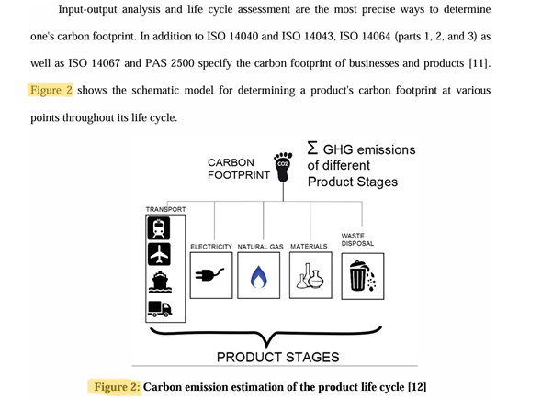

Tables
1. Each table should be numbered sequentially and accompanied by a descriptive caption, centered directly above the table.
2. Tables must be submitted in an editable format (not as images or figures).
3. Ensure that all tables are properly referenced, and each one must be cited appropriately within the main text.
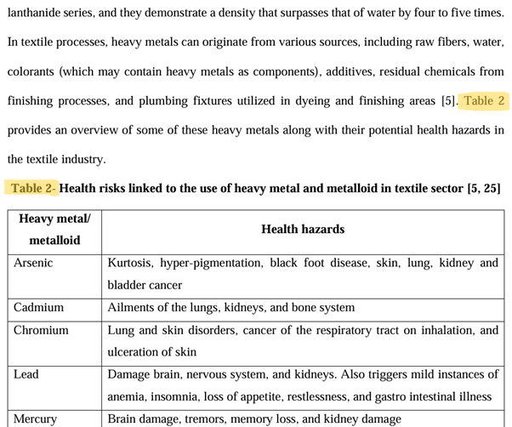
References
1. Follow APA 7th edition format as reference style and numbering in intext citation.
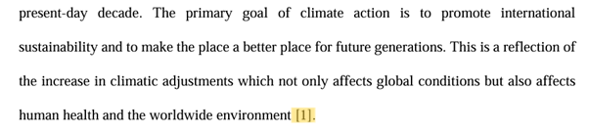
2. All the references should be cited within the text
3. All the tables and figures must be provided with references
4. Provide an image with high resolution.
5. All the charts and graphs should be titled as figures.
6. Provide references for every image properly, and do not add links below figures as references.
7. Use only copyright-free images or use images with proper permissions.

General Instructions

The following criteria must be met for a full manuscript to be considered for review:
Acceptance of the abstract for FTSC 2027 grants approval for full paper submission but does not imply acceptance of the full paper. The full manuscript will undergo a separate review by the International Programme Committee before a final decision is made.
1. Page Limit
Each paper should be between 15 to 20 pages in the prescribed format.
2. Manuscript Structure Each paper must include (though not necessarily in the order listed) the following sections:
Objectives, Research Questions/Hypotheses: Clearly state the research objectives, key questions, or hypotheses addressed in the study.
Motivation & Background: Explain the significance of the research and its potential impact.
Research Approach & Methodology: Describe the research methods, processes, and steps taken to achieve the objectives.
Findings: Present key results and discuss their relevance to the objectives/questions/hypotheses.
Summary & Conclusions: Summarize findings, evaluate research methodology, highlight limitations, and outline future scope.
References: Cite at least 25 peer-reviewed sources from academic journals, conferences, books, or reports.

3. Originality & Academic Rigor:
The manuscript must present original research that contributes new knowledge to academia and practice. A critical review of existing literature is essential to establish novelty and significance.
4. Plagiarism & AI Usage:
All submissions will be checked for plagiarism. Papers with more than 10% overlap will be automatically rejected. AI-generated papers will not be accepted. The publishers will conduct AI-detection checks. If AI tools are used to assist with any part of the paper, authors must explicitly declare this in the Acknowledgement section. The Programme Committee reserves the right to reject submissions if AI involvement compromises originality.

